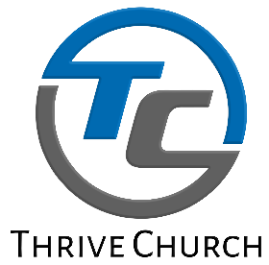

QUICK TIPS FOR STUDYING THE BIBLE

- PRAY – Ask the Holy Spirit to lead you as you read and to reveal to you The Truth of what is written.

- READ SLOWLY – Some read fast and carelessly but scripture is meant to be read slowly and carefully that we might understand it better.

- READ CHAPTERS, NOT JUST VERSES – It’s important to know what is written before and after the verse to be able to get a full understanding of who wrote it and to whom was it written. Why was it written and what was the current culture and times the people of that day were living in. Then you will be able to clearly know how it is to be applied to your life today.

- LET SCRIPTURE INERPRET SCRIPTURE – When you find other places in the bible that speak to the same subject it will give a fuller and clearer picture of what is being spoken and what is meant.

- STUDY WITH OTHERS – Reading alone is good for personal devotions but studying with others helps by bring different perspectives and experiences to hep arrive at a better conclusion.

- JOURNAL/TAKE NOTES – Writing down things you read especially what The Holy Spirit speaks to you are always good to go back and reference from time to time. It is also helpful to write down questions and go back when the answer is found.

- DON’T JUST READ THE BIBLE, LET IT READ YOU – The bible will reveal many things to you about you, that’s a good thing.

- REMEMBER, THE BIBLE INFORMS BUT MORE IMPORTANTLY IT TRANSFORMS
The bible will give you incredible information and inspiration but without application it will never lead to true transformation. Apply the truth of God’s Word and your life will never be the same.

